1. How many types of users are there for this system?

**Ans:** 1 type of users

Identify these types of users

* แอดมิน

1. Draw a use case diagram demonstrating the relationship between sub-systems and these type of users

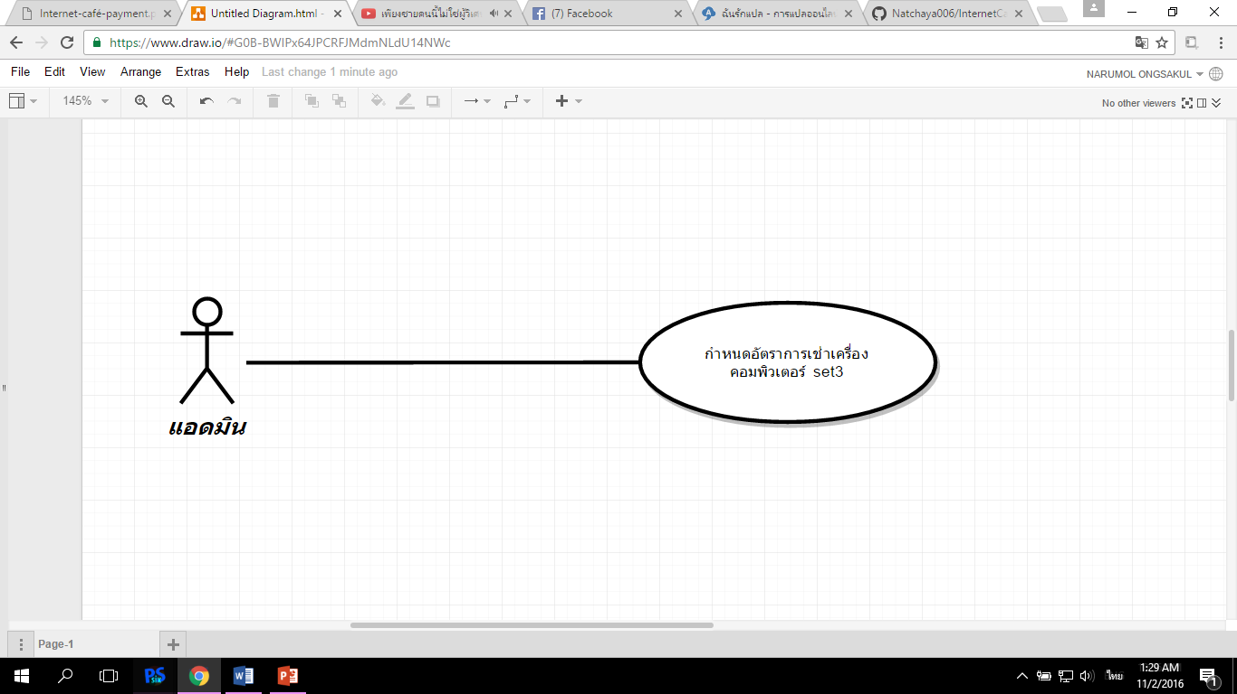

1. Draw a use case diagram identifying modules Update an existing customer data. Identify the relationship between these modules and each type of users.

**2.3 Set up the computer rental rate.**

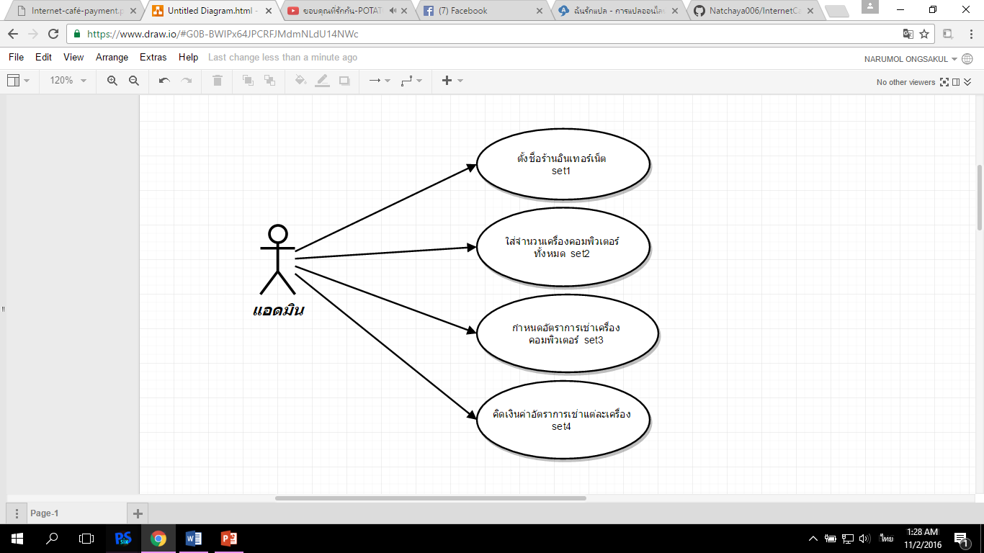

1. From instruction 3, write the user requirement definition for module Update an existing customer data by using the use case scenario technique.

**2.3 Set up the computer rental rate.**

|  |  |
| --- | --- |
| Use Case Name:: | **::** |
| Xref:: | **[Internet café payment]/ Use Case: set3 /pg.4** |
| Actor:: | **แอดมิน** |
| Priority:: | High |
| Status:: | Complete |
| Pre-conditions /Assumptions:: |  |
| Post-conditions:: |  |
| Flow of Events:: |  |
| Alternative Paths:: | **[A1]  [A2]** |
| Exception Paths:: | **[E1]**  **[E2]** |
| Note:: |  |

1. From instruction 4, write the system requirement specification for describing the user requirement definition in details by using the standard form technique

**Use Case: set3**



**Initial Step-By-Step Description**



**Xref: [Internet café payment]/2.3/pg.3**